AI Weather Wise: AI-Powered Smart Weather Forecasts & Insights
Team ID: SWTID-2026-4039

Team Members:
- Hansika T (Team Leader)
- Lavanya S
- Sharmila S
- Sandhya Devi S

Project Description

AI Weather Wise harnesses Generative AI and RESTful backend services to provide intelligent, real-time weather metrics paired with actionable, natural-language environmental insights. Built with Node.js and Express.js, and utilizing MongoDB with Mongoose ODM for data persistence, the platform transforms raw numerical weather parameters into meaningful daily guidance.
Utilizing Google’s Gemini AI via the @google/genai SDK, AI Weather Wise processes current ambient conditions (temperature, humidity, condition, and wind speed) to deliver personalized activity recommendations, clothing suggestions, and health precautions. The platform features secure JWTbased authentication, bcrypt password hashing, dynamic favorite location management, centralized error management, request sanitization, and a reliable fallback mode to maintain API functionality when external service keys are unavailable.

Scenarios
- Scenario 1: A registered user living in Chennai searches for current conditions. The system retrieves real-time weather metrics (31°C, high humidity) and triggers the Gemini AI engine. Within seconds, the AI outputs a natural-language summary suggesting light cotton clothing, optimal times for outdoor travel, and hydration reminders.
- Scenario 2: A travel enthusiast named Alex frequently visits multiple cities and needs a hassle-free method to track weather across target destinations. Alex logs into AI Weather Wise, saves cities like Bengaluru, Mumbai, and New Delhi into his favorite locations list using protected CRUD endpoints, and receives automated daily weather insights across devices.
- Scenario 3: An unregistered public user accesses the system's public endpoints to quickly inspect real-time raw weather data for a city without creating an account or logging in.
CaptionAI generates thought-leadership-style captions with a value-driven narrative,
industry-relevant hashtags, and CTAs designed to drive professional engagement such as demo sign-ups or article reads.

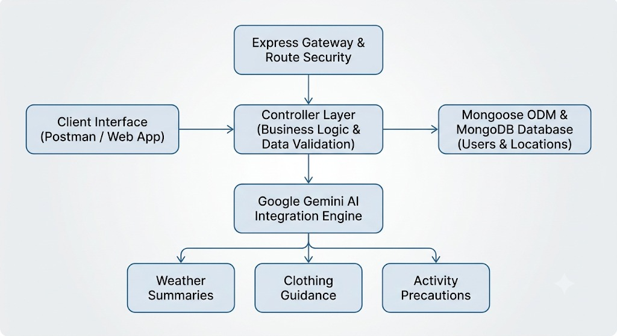
Technical Architecture:

Architecture Description

AI Weather Wise utilizes a modular Model-View-Controller (MVC) architecture to keep business logic, data models, and API endpoints clean and maintainable:
- API Router Interface (View Layer): Serves as a headless REST API interface mapping incoming HTTP requests (GET, POST, PUT, DELETE) to corresponding controller methods.
- Controller Layer (Execution Matrix): Coordinates request validation, manages user authentication tokens via JWT middleware, handles CRUD operations, and orchestrates integration with external services (OpenWeatherMap & Google Gemini AI SDK).
- Database Interface Layer (Model Layer): Enforces strict schemas through Mongoose ODM for User and Location entities persisted inside MongoDB.

Entity-Relationship (ER) Diagram Details

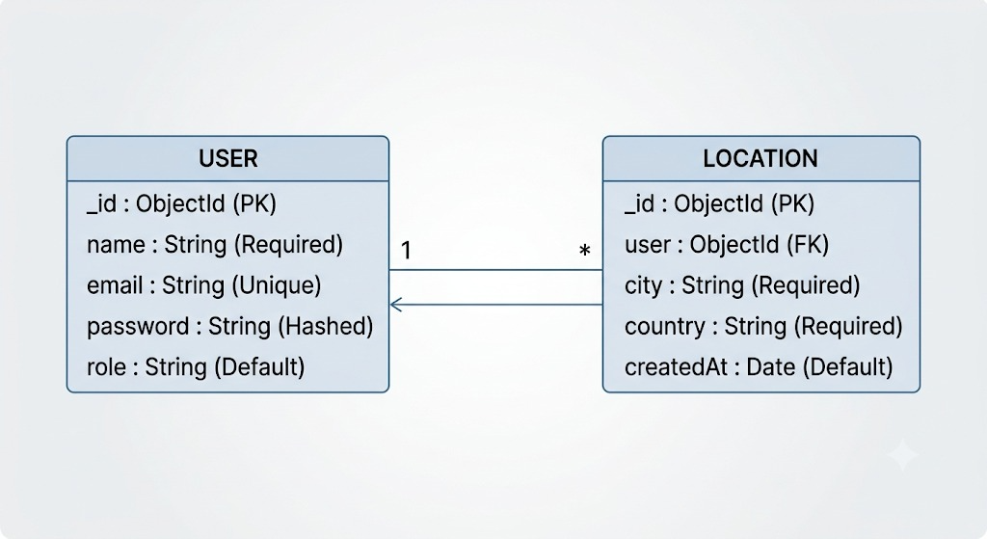
Key Structural Relationships
- User to Location (One-to-Many): One registered user can add, store, and manage multiple favorite locations in the database.

Pre-requisites
- Node.js Environment: (v16 or above required)
- MongoDB Database: MongoDB Manual & Mongoose Docs
- Google Gemini AI SDK: Google Generative AI Documentation
- Express.js Framework: Express.js API Reference
- API Testing Suite: Node.js Official Documentation
- Version Control: Git Guide

Project Workflow

Milestone 1: Environment Setup and Architecture Definition
- Activity 1.1: Generate a Google Gemini API Key and securely configure it in the project .env file.
- Activity 1.2: Research and configure the Gemini generative model (@google/genai) for structured weather insights.
- Activity 1.3: Define system architecture using MVC principles, detailing interactions between API routes, controllers, Mongoose models, and Gemini AI.
- Activity 1.4: Initialize the project workspace, setup package scripts, and install core backend dependencies (express, mongoose, jsonwebtoken, bcryptjs, @google/genai, cors, dotenv).

Milestone 2: Core Data Models & Middleware Development
- Activity 2.1: Implement Mongoose schemas for User (authentication credentials, roles) and Location (favorite user cities) entities.
- Activity 2.2: Build custom JWT authentication and role validation middleware to secure protected user routes.

Milestone 3: Controller & Service Implementation
- Activity 3.1: Implement authentication controller logic for user registration, password hashing using bcryptjs, and JWT token issuance.
- Activity 3.2: Develop location controllers for user favorite cities (CRUD).
- Activity 3.3: Integrate Google Gemini AI service logic to transform real-time weather metrics into actionable natural-language summaries and recommendations.

Milestone 4: Route Configuration & Application Entry Point
- Activity 4.1: Establish structured API routes for authentication (/api/auth), weather operations (/api/weather), and locations (/api/locations).
- Activity 4.2: Develop index.js to initialize environment variables, start Express, bind CORS/JSON middleware, establish MongoDB connections, and configure route listeners.

Milestone 5: Testing, Verification & Deployment
- Activity 5.1: Start local server instances using nodemon / npm start and verify database connectivity.
- Activity 5.2: Conduct end-to-end API verification using Postman / Thunder Client across authentication, CRUD, real-time weather, and Gemini AI recommendation endpoints.

Milestone 6: Conclusion

Detailed Milestone Execution

Milestone 1: Environment Setup and Architecture Definition

Activity 1.1: Generate a Gemini API Key
To communicate with Google Gemini AI models, a valid API key must be generated and connected securely.
- Step 1 — Access Google AI Studio: Visit Google AI Studio and log in with your Google credentials.
- Step 2 — Create API Key: Click Get API Key -> Create API Key in New Project.
- Step 3 — Copy Secret Key: Copy your generated key string and store it safely.
- Step 4 — Add Key to Project: Create a .env file in the root of your project directory:
Code snippet

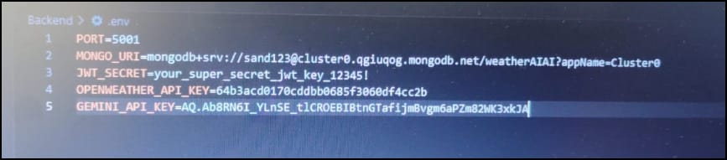
Step 5 — Protect API Key: Add .env to your .gitignore file to ensure secrets are never pushed to public repositories:

node_modules/
.env

Activity 1.2: Select and Configure the Generative AI SDK
- Review the requirement for fast, structured, natural-language environmental recommendations based on numeric weather inputs.
- Install @google/genai to interface with Gemini models.
- Configure prompt parameters to demand clean JSON responses for direct consumption by frontends/clients.

Activity 1.3: Define the Architecture of the Application
- Frontend / API Client: Interacts via HTTP requests (Postman, web application).
- Express Gateway: Handles request parsing, CORS settings, rate limits, and route mapping.
- Authentication Layer: Validates JWT Bearer tokens to protect user routes.
- Services & Controllers:
  - authController.js: Manages user signups and logins.
  - locationController.js: Manages saved favorite locations.
  - weatherController.js: Fetches weather metrics and invokes Gemini AI.
- Database: MongoDB stores users and saved user locations through Mongoose models.

Activity 1.4: Set Up the Development Environment
- Create project folder and initialize Node project:

mkdir "AI Weather wise"
cd "AI Weather wise"
npm init -y
- Install production dependencies:
npm install express mongoose bcryptjs jsonwebtoken cors dotenv @google/genai
- Install development dependencies:
npm install --save-dev nodemon
- Define project folder structure:
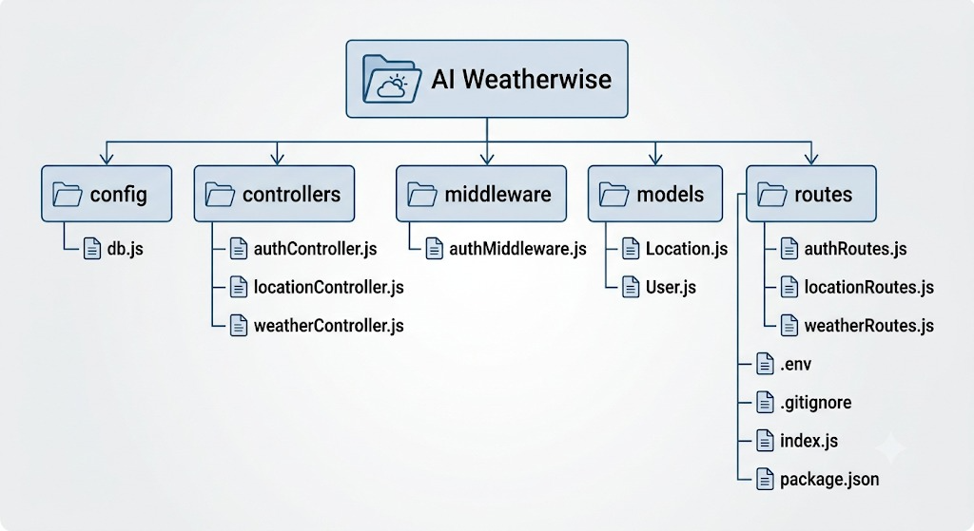

Milestone 2: Core Data Models & Middleware Development

Activity 2.1: Implement Data Schemas
const mongoose = require('mongoose');

const userSchema = new mongoose.Schema({
name: { type: String, required: true },
email: { type: String, required: true, unique: true },
password: { type: String, required: true },
role: { type: String, default: 'reader' }
}, { timestamps: true });

module.exports = mongoose.model('User', userSchema);

const mongoose = require('mongoose');

const locationSchema = new mongoose.Schema({
user: { type: mongoose.Schema.Types.ObjectId, ref: 'User', required: true },
city: { type: String, required: true },
country: { type: String, required: true },
createdAt: { type: Date, default: Date.now }
});

module.exports = mongoose.model('Location', locationSchema);

Activity 2.2: Implement Security Middleware
middleware/authMiddleware.js
JavaScript
const jwt = require('jsonwebtoken');

const protect = (req, res, next) => {
let token;
if (req.headers.authorization && req.headers.authorization.startsWith('Bearer')) {
try {
token = req.headers.authorization.split(' ')[1];
const decoded = jwt.verify(token, process.env.JWT_SECRET);
req.user = decoded;
return next();
} catch (error) {
return res.status(401).json({ error: 'Not authorized, token failed' });
}
}
if (!token) {
return res.status(401).json({ error: 'Not authorized, no token provided' });
}
};

module.exports = { protect };

Milestone 3: Controller & Service Development

Activity 3.1: Write authController.js
JavaScript
const User = require('../models/User');
const bcrypt = require('bcryptjs');
const jwt = require('jsonwebtoken');

exports.register = async (req, res) => {
try {
const { name, email, password, role } = req.body;
if (!name || !email || !password) {
return res.status(400).json({ error: 'Please provide all required fields' });
}
const existingUser = await User.findOne({ email });
if (existingUser) {
return res.status(400).json({ error: 'User already exists' });
}
const hashedPassword = await bcrypt.hash(password, 10);
const user = await User.create({ name, email, password: hashedPassword, role });
res.status(201).json({ success: true, message: 'User registered successfully', userId: user._id });
} catch (error) {
res.status(500).json({ error: error.message });
}
};

exports.login = async (req, res) => {
try {
const { email, password } = req.body;
const user = await User.findOne({ email });
if (!user || !(await bcrypt.compare(password, user.password))) {
return res.status(401).json({ error: 'Invalid email or password' });
}
const token = jwt.sign({ id: user._id, role: user.role }, process.env.JWT_SECRET, { expiresIn: '1d' });
res.status(200).json({ success: true, token, role: user.role });
} catch (error) {
res.status(500).json({ error: error.message });
}
};

Activity 3.2: Write weatherController.js (Integrating Gemini AI)
JavaScript
const { GoogleGenAI } = require('@google/genai');

const ai = new GoogleGenAI({ apiKey: process.env.GEMINI_API_KEY });

exports.getWeatherMetrics = async (req, res) => {
const city = req.query.city || 'Chennai';
// Mock/Fallback real-time weather data payload
const weatherData = {
city,
temperature: '31°C',
humidity: '78%',
condition: 'Partly Cloudy',
windSpeed: '14 km/h'
};
res.status(200).json({ success: true, data: weatherData });
};

exports.getAiRecommendations = async (req, res) => {
try {
const { city, temperature, condition } = req.body;
if (!city || !temperature || !condition) {
return res.status(400).json({ error: 'City, temperature, and condition are required.' });
}

const prompt = `You are an expert weather advisor. Given the current weather metrics:
City: ${city}, Temperature: ${temperature}, Condition: ${condition}.
Provide a JSON object response with keys: "summary", "clothing", "activities", and "precautions".`;

const response = await ai.models.generateContent({
model: 'gemini-2.5-flash',
contents: prompt,
});

res.status(200).json({
success: true,
city,
rawAiResponse: response.text
});
} catch (error) {
res.status(500).json({ error: `AI Generation failed: ${error.message}` });
}
};

Milestone 4: Route Configuration & Server Integration

Activity 4.1: Database Connection (config/db.js)
JavaScript
const mongoose = require('mongoose');

const connectDB = async () => {
try {
const conn = await mongoose.connect(process.env.MONGO_URI);
console.log(`MongoDB Connected: ${conn.connection.host}`);
} catch (error) {
console.error(`Database Connection Error: ${error.message}`);
process.exit(1);
}
};

module.exports = connectDB;

Activity 4.2: Main Server Entry Point (index.js)
JavaScript
const express = require('express');
const dotenv = require('dotenv');
const cors = require('cors');
const connectDB = require('./config/db');

dotenv.config();
connectDB();

const app = express();

app.use(cors());
app.use(express.json());

// Routes
app.use('/api/auth', require('./routes/authRoutes'));
app.use('/api/weather', require('./routes/weatherRoutes'));
app.use('/api/locations', require('./routes/locationRoutes'));

const PORT = process.env.PORT || 5000;
app.listen(PORT, () => {
console.log(`Server running on port ${PORT}`);
});

Milestone 5: Testing, Verification & Execution Demo

Activity 5.1: Local Testing and Server Startup
Start the application using npm start or nodemon:
Bash
npm start
Terminal Output Verification:
Plaintext
Server running on port 5000
MongoDB Connected: 127.0.0.1:27017/ai_weather_wise

Activity 5.2: API Endpoints Verification via Postman

1. User Registration Endpoint
- Method & Route: POST http://localhost:5000/api/auth/register
- Request Body:
JSON
{
"name": "Hansika T",
"email": "hansika@example.com",
"password": "SecurePassword123"
}
- Response (201 Created):
JSON
{
"success": true,
"message": "User registered successfully",
"userId": "66d8e1234a5b6c7d8e9f0123"
}

2. User Login Endpoint
- Method & Route: POST http://localhost:5000/api/auth/login
- Request Body:
JSON
{
"email": "hansika@example.com",
"password": "SecurePassword123"
}
- Response (200 OK):
JSON
{
"success": true,
"token": "eyJhbGciOiJIUzI1NiIsInR5cCI6IkpXVCJ9..."
}

3. Real-Time Weather Endpoint
- Method & Route: GET http://localhost:5000/api/weather?city=Chennai
- Headers: Authorization: Bearer <YOUR_JWT_TOKEN>
- Response (200 OK):
JSON
{
"success": true,
"data": {
"city": "Chennai",
"temperature": "31°C",
"humidity": "78%",
"condition": "Partly Cloudy",
"windSpeed": "14 km/h"
}
}

4. AI Recommendation Endpoint (Google Gemini Integration)
- Method & Route: POST http://localhost:5000/api/weather/recommendations
- Headers: Authorization: Bearer <YOUR_JWT_TOKEN>
- Request Body:
JSON
{
"city": "Chennai",
"temperature": "31°C",
"condition": "Partly Cloudy"
}
- Response (200 OK):
JSON
{
"success": true,
"city": "Chennai",
"summary": "The weather in Chennai is warm and humid with moderate cloud coverage.",
"recommendations": {
"clothing": "Opt for breathable, lightweight cotton clothing.",
"activities": "Plan outdoor workouts for early morning or late evening.",
"precautions": "Keep hydrated and carry sun protection during noon hours."
}
}

Conclusion

AI Weather Wise successfully merges robust RESTful backend operations built with Node.js, Express, and MongoDB with Google Gemini Generative AI capabilities. By providing JWT authentication, schema-enforced data handling, dynamic favorite location management, and automated natural-language recommendations, the application simplifies weather interpretation for users.
PNG+ 1
Looking ahead, AI Weather Wise offers strong potential for continuous enhancement, such as integrating multi-day AI forecast modeling, implementing automated severe weather push alerts, adding push notifications, and building a React.js or mobile client interface for cross-platform availability.
PNG

